Occurrence and Associative Value of NonIdentifiable Fingermarks on Unfired Ammunition in Handguns

David A. Stoney,ª Marco De Donno,^{b} Christophe Champod,^{b} Pat A. Wertheim,^{c} Maria Cuellar^{d} and Paul L. Stoneyª

ª Stoney Forensic, Inc.
14101-G Willard Road
Chantilly, VA 20151-2934 USA
david@stoneyforensic.com; paul@stoneyforensic.com

^{b} School of Criminal Justice, Faculty of Law, Criminal Justice and Public Administration, Batochime, Quarter Sorge, CH-1015 Lausanne-Dorigny, Switzerland
Marco.DeDonno@unil.ch; christophe.champod@unil.ch

^{c} Deceased

^{d} University of Pennsylvania, Department of Criminology and Department of Statistics and Data Science, United States of America
mcuellar@sas.upenn.edu

Corresponding Author:

David A. Stoney
Stoney Forensic, Inc.
14101-G Willard Road
Chantilly, VA 20151-2934 USA
david@stoneyforensic.com
+ 1 703 362 5983

Abstract

This research explored the use of Non-Identifiable Fingermarks (NIFMs) on loaded ammunition to link suspects with firearms. NIFMs are fragmentary, partial fingerprints that are insufficient for identification. Current forensic science practices set these fingermarks aside, leaving them unexamined. However, prior research has shown that NIFMs have strong associative value. Accordingly, they represent an untapped source of information with a strong potential for supporting criminal investigations and legal proof.

The motivation for this work was to perform a realistic test of the actual contribution of NIFMs when applied to an extremely important evidentiary problem. The specific research goal was to answer the question of how often NIFMs occur on naturally loaded handgun ammunition and what range of associative values can be expected. By comparing these results to those obtained from using only identifiable fingerprints, the potential impact of NIFMs is illuminated.

As a realistic test, unfired ammunition was collected from handguns after they had been loaded by their owners, each using newly purchased ammunition and their accustomed loading practices. The ammunition cartridges were processed for fingerprints using commonly employed forensic laboratory methods and all fingermarks showing four or more ridge characteristics were considered. Expert examination of these marks determined which were identifiable (conventionally used fingerprints) and which were NIFMs. Associative values of the marks (estimating how often a match might occur at random) were determined using a well-defined, calibrated method.

1263 rounds of ammunition were collected from 164 handguns. Fingermarks judged identifiable (64) were found on 4.7% of rounds representing 21.3% of handgun loads. When NIFMs were considered (another 414 fingermarks), the number of rounds rose to 27.2%, representing 65.9% of handgun loads. According to international reporting guidelines, 80% of the NIFMs provided strong support for association (as in a random match occurring less than once in a thousand times). Although differences in the numbers of NIFMs found were seen among different ammunition calibers and handgun types, each group showed NIFMs with strong association on at least 1 in 5 ammunition cartridges.

The findings indicate that NIFMs of high associative value occur commonly on loaded handgun ammunition. For this application it has been shown under realistic operational conditions that a six-fold increase in useful associative information results when NIFMs are included along with conventional fingerprints. This finding is reasonably generalized to expect a similar increase when NIFMs are sought on other items collected as evidence, or as part of the general fingerprint processing of crime scenes.

This is an extraordinary potential contribution – and one that does not require any additional investment in crime laboratory equipment nor any additional personnel skills. The use of NIFMs warrants immediate attention, with application to criminal investigations, the development and testing of alternative implementation protocols, validation of these protocols, and development of robust quality assurance procedures.

Keywords: fingerprints; non-identifiable fingermarks; ammunition, associative value

I. Introduction

Among the most serious and pervasive criminal offenses in our society are the possession of handguns by convicted felons and handgun use in the commission of crime. Evidence of who loaded a recovered handgun is important for the proof of criminal possession, use, or intent.

Laboratory methods, including the analysis of loaded ammunition for identifiable fingermarks and DNA, can provide this evidence. However, both methods have limitations. DNA analyses are time-consuming, costly and often confounded by mixtures, degradation or the possibility of secondary transfer. Likewise (despite abundant and ongoing research) identifiable fingermarks are very rarely found on the small slippery surfaces of ammunition [1-7]. Non-identifiable finger marks (NIFMs) offer an intriguing possibility to address these limitations.

Prior research [8, 9] has found that NIFMs occur frequently on evidence items and at crime scenes and that most have high associative value. This suggests that NIFMs on handgun ammunition could provide important evidence. However, it is unknown how often, and with what level of associative value, NIFMs occur on loaded handgun ammunition. Small, highly curved metal surfaces and rapid handling decrease the likelihood that useful prints will be left. Does sufficient fingerprint detail for high associative value commonly remain on loaded ammunition? Does this vary by caliber and handgun type?

The answers are important. If NIFMs of high associative value occur commonly on loaded ammunition, this could be a major additional source of information. Current practices could be routinely setting aside information that is directly relevant to the investigation and prosecution of violent crime. Alternatively, if the added information is very limited or rarely occurring, NIFMs on ammunition may not justify additional laboratory, investigative or prosecutorial attention.

In this research ammunition from handguns loaded by their owners has been recovered and processed for latent fingermarks. Occurrences of identifiable fingermarks and NIFMs have been documented, and expected associative values of NIFMs were determined based on a well-defined, currently available, calibrated approach. Frequencies were measured for the overall recovery of NIFMs, and their distribution of expected associative values, for revolvers and semi-automatic pistols covering a range of common calibers.

II. Materials and Methods

A. Collection of Unfired Ammunition from Handguns
The differences in available surface area and curvature among different calibers of ammunition are known to affect the recovery of identifiable fingermarks. [10, 11] To achieve a reasonably representative set of ammunition, collections were made from loaded semi-automatic and revolver handguns covering a range of caliber classes from .22 through .45. Ammunition was collected directly from firearms that were loaded previously by their owners, without any specific guidance or requirements for preparation of ammunition, washing of hands, or loading technique.

B. Visualization and Imaging of Fingermarks on the Collected Ammunition
Fingermarks were visualized on the cylindrical surfaces of each of the ammunition cartridges using two well-established methods: cyanoacrylate fuming (CA, superglue), followed by fluorescent dye staining (using the dye BY-40). CA was applied to all cartridges. BY-40 was applied to any cartridge where the CA treatment did not result in a fingermark bearing 4 or more ridge characteristics showing clear relationships to one another.

CA Processing
CA processing was performed using commercially available fuming equipment (Air Science® Safefume™ Model CA30S). The fuming cabinet allows programmable treatments incorporating processing time, humidity control, air circulation and heat-induced polymerization of cyanoacrylate.

Within the processing chamber a cartridge suspension system was designed as shown in Figure 1. Cartridges were individually suspended from the chamber’s vinyl-coated wire rack using pencil-sized, plunger-activated claw tweezers. The ends of the tweezers are conveniently held within one the rectangular (~ 25 x 50 mm) openings of the rack using a ~38 mm diameter notched acrylic disc. This system allows rapid mounting and removal of specimens, regular spacing, and reference to specimen positions using the wire grid row and column “coordinates.”

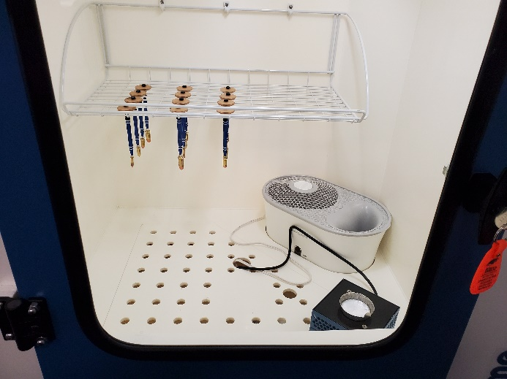
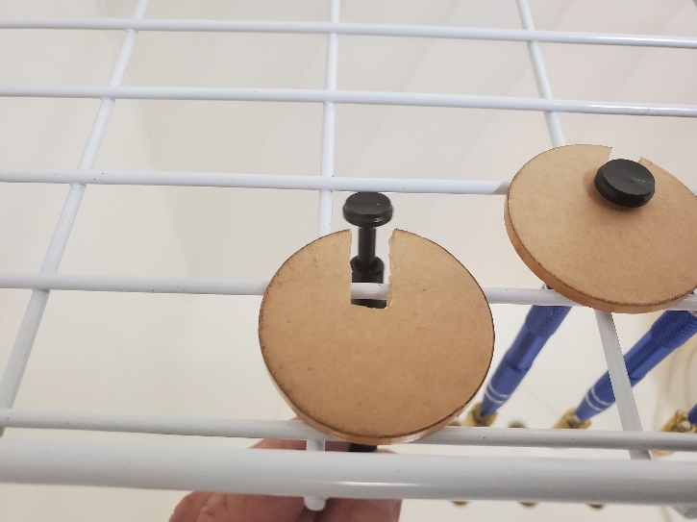

Figure 1. Ammunition cartridges suspended individually using claw tweezers in the cyanoacrylate fuming chamber (left) and close-up of the suspension method using acrylic disks (right).

CA processing parameters were tested to accommodate laboratory and environmental conditions as encouraged by the International Fingerprint Research Group [12]. Initial conditions (based on the fuming cabinet manufacturer recommendations) used 6.0 mL cyanoacrylate, 15 minutes processing time and relative humidity of 80% (+/- 5%). These conditions were sufficient for visualization of latent prints but showed a pronounced over-development (background reaction). Holding the other processing steps constant, the amount of cyanoacrylate was systematically reduced until the background reaction was clear, while maintaining clear visibility of the fingerprint residues. Under our experimental conditions a volume of 250 µL of cyanoacrylate was sufficient.

Fluorescent Dye Staining
Fluorescent dye staining using BY40 was applied to cartridges previously treated by CA.
Following the procedure of Girelli et al. [13] cartridges were dipped into BY40 Premix (Evident) for 10 sec. They were then rinsed by dipping in three successive 100 mL breakers of distilled water and air dried. Fluorescence of the dye was excited using a forensic light source (Polylight PL500) at 395-400 nm and visualized using a 590 nm barrier filter.

Fingermark Imaging
An imaging system for “cylindrical unwrapping” was constructed as shown in Figure 2, following the schematic design and description of Porter et al. [14] Cartridges to be photographed are rotated before the camera using a panoramic tripod head and a series of images are taken. These are then stitched together using imaging software, providing a flat composite image of fingerprints that are found on the cylindrical cartridge surface.

Following Porter’s specifications, we employed a Manfrotto™ panoramic tripod head, Canon EOS 50D digital SLR camera, and 100 mm macro lens. We also employed his lighting conditions applicable to fluorescing fingerprints (Rofin OG590 barrier filter, Polilight PL500 mounted for near coaxial illumination). The mounting apparatus, shown and described in Figure 2, incorporates several modifications to the system as described by Porter:
- Addition of a leveling base beneath the panoramic head
- Employment of a drill chuck, holding an inverted cartridge to serve as a specimen platform (as an alternative to a brass spigot)
- Mounting of the camera and Polilight light guide to a lab jack, providing simultaneous height adjustment
- Bolting both the lab jack (with camera and Polilight) and the leveling base (with panoramic head and drill chuck) securely to a photographic platform

Figure 3 illustrates and describes the diffuse illumination method used for direct (non-fluorescent) photography of fingermarks (following CA development).

Following [14], fingermark ridge detail appearing on the cartridges was photographed with images taken every 24 degrees rotation of the panoramic head for all cartridge calibers other than 22, and every 30 degrees rotation for the caliber 22. Images were cropped, processed and merged for “cylindrical unwrapping” of the cartridge surface, and stitching the complete print as illustrated in Figure 4.

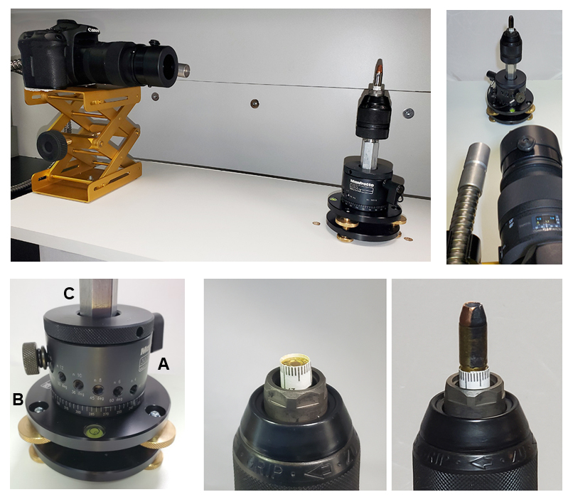

Figure 2. Top Left: Overview of the photographic platform with camera and Polilight light guide mounted on a laboratory jack and the specimen mounting apparatus. Both are bolted to the photographic platform. Top Right: Camera view of the specimen mounting apparatus showing the Polilight light guide providing near coaxial illumination. Lower Left: The panoramic tripod head (A) is mounted on levelling base (B). An aluminum male-female thread adaptor (C) at the top of the panoramic tripod head is used to attach a keyless drill chuck. Lower Right: The photograph to the left shows the chuck gripping a sample holder. Sample holders are constructed for each cartridge diameter by inverting a round of ammunition and wrapping a band of tape marked with a millimeter scale around the base. The tape is wrapped with the edge extending 1 mm beyond the casing. This provides a recessed cup for the specimen. The right image shows the specimen in position, with the tape edge providing stability.

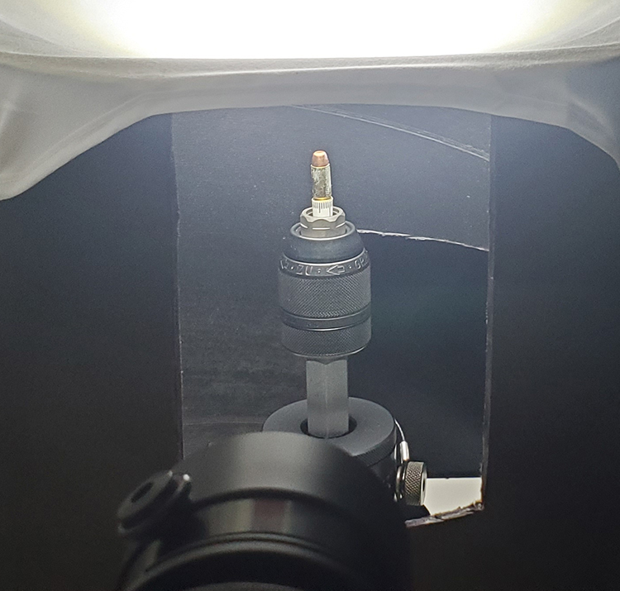
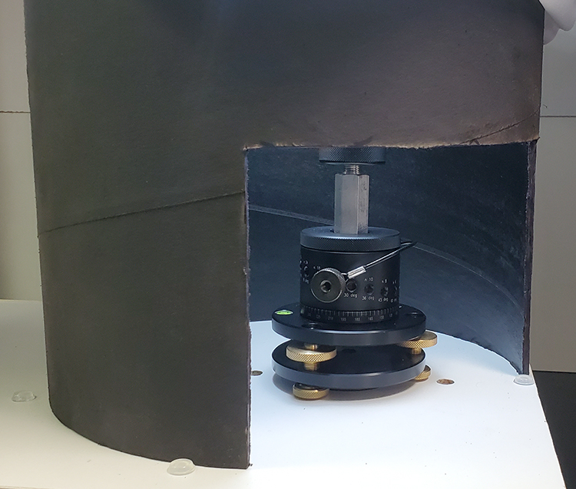
Figure 3. Diffuse lighting for non-fluorescing fingermarks. A flat-black cardboard cylinder (~ 30 cm diameter) surrounds the specimen mount with openings toward the camera and in the right rear quadrant, below the specimen. The left image shows the specimen mounting apparatus within the cardboard cylinder, as viewed from the camera direction. Diffuse white light enters from above. The rear opening to the cylinder is to the lower right. The right image shows the specimen mounting apparatus as viewed through the rear opening. This opening provides access to the panoramic tripod head, so that it can be rotated to expose successive views of the specimen.

Figure 4. Example of the cylindrical unwrapping process for one of the specimens. This fingermark was developed by cyanoacrylate fuming on a .32 ACP cartridge. The original photographs (above) are taken in sequence, rotating the specimen 24 degrees between exposures. These are cropped, resulting in a series of images (lower left). These are combined using Photoshop’s Photomerge™ function to produce the composite image of the fingermark (lower right).

C. Expert Examination of Fingermarks and Annotation of Minutiae
Images of candidate fingermarks were examined by a highly experienced certified latent print examiner (PW) and minutiae (ridge characteristics) were annotated and documented as shown in Figure 5. Fingermarks were accepted where 4 or more minutiae were present in a clear relationship to one another in the context of the ridge flow. Fingermarks were also graded as either Of Value for Identification (meeting traditional requirements for a fingerprint identification) or No Value (a non-identifiable fingermark, NIFM).

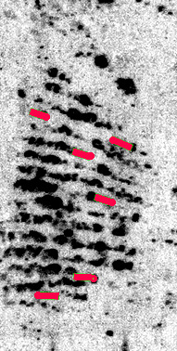
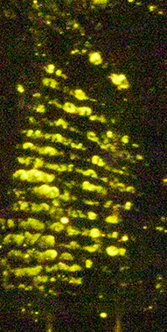
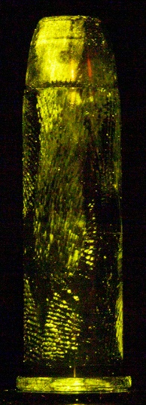

Figure 5. Photograph of an ammunition cartridge after CA and BY-40 processing (left) and candidate NIFM (center). To the right is the corresponding annotated fingermark after image processing to enhance contrast and expert examination to determine the number and positions of the minutiae (ridge characteristics). This is a NIFM showing 6 minutiae.

E. Statistical Analysis
Statistical analyses were conducted at the cartridge, mark, and handgun-load levels to reflect the nested structure of the data. Cartridge-level occurrence outcomes were summarized using the number of tested cartridges recorded in LOADS as the denominator and the number of unique load-cartridge pairs with one or more observed fingermarks as the numerator. Exact 95% confidence intervals were used to quantify uncertainty for reported proportions. Comparisons across handgun type and caliber category were formalized using grouped binomial models. Because multiple cartridges arose from the same handgun load, clustered or load-level resampling methods were used when estimating uncertainty for differences and ratios comparing identifiable fingermarks alone with the combined yield obtained when NIFMs were included. For analyses of associative value, ESLR and Log10 ESLR summaries were reported for observed marks, with interpretations conditioned on the marks being observed.

The associative values of the fingermarks were determined based on their annotated minutiae, using a well-established method, fully described in [8], that compares random non-matching scores from a large fingerprint database with a range of scores obtained from the true source. The result is an “Expected Score-Based Likelihood Ratio” or ESLR, derived from the modeling of within-variability (true source) and between-variability (different sources) of scores resulting when an automated fingerprint identification system (AFIS) measures the similarity between two fingermarks. The ESLR provides a measure of strength of association. For example, an ESLR of 1000 shows the same strength of association as a feature that would occur randomly at a rate of one time in a thousand.

III. Results
A. Ammunition Collection
1263 ammunition cartridges were collected from 164 handguns. Table 1 shows the distribution of these by type of handgun (semi-automatic vs revolver) and caliber class. The four caliber classes used were 22 (.22LR); 32 (.32 ACP); 38 (including .38 Special, .357 Magnum, .380 ACP and 9mm); and 45 (including .45 ACP, .45 Colt, .44 Magnum and .40 S&W).

Table 1. Ammunition Cartridges Collected
Caliber Class | Revolver | Semi-  Automatic | Totals by Caliber Class
22 | 225 | 198 | 423
32 | 0³ | 105 | 105
38¹ | 107 | 348 | 455
45² | 102 | 178 | 280
Totals by Handgun Type | 434 | 829 | 1263

¹ Including .38 Special, .357 Magnum, .380 ACP and 9mm ammunition
² Including .45 ACP, .45 Colt, .44 Magnum and .40 S&W ammunition

³ .32 caliber revolvers are very rare and none are represented
2. Processing of the Collected Ammunition for Fingermarks

B. Fingermark Processing and Expert Evaluation
Processing of the 1263 ammunition cartridges resulted in 1819 candidate fingermark images for expert evaluation. This evaluation resulted in 478 fingermarks with 4 or more minutiae, appearing on 344 of the cartridges.

The distribution of these 478 fingermarks by handgun type and caliber class is shown in Table 2. Overall, 27.2% of the cartridges showed one or more 4+ minutiae fingermarks (with an average of 1.39 marks per cartridge when present). The different ammunition classifications ranged from a low of 20.4% of cartridges (22 revolvers) to a high of 44.9% (38 revolvers).

Table 3 shows that identifiable fingermarks were found on only 4.7% of the cartridges. Without consideration of NIFMs, this leaves the other 95.3% of the cartridges without associative fingermark findings. When the 414 NIFMs are included, the number of cartridges with fingermark findings increases by 285 to a total of 344. Useful fingermarks with high associative value are found on nearly 6 times as many cartridges when NIFMs are included.

The numbers of annotated minutiae for the 478 fingermarks are given in Table 4 showing the distribution among handgun type and caliber class. Differences among these categories are charted in Figure 6, which shows the numbers of NIFMs found exceeding a given number of minutiae, per 100 ammunition cartridges examined.

For example, following the gray line in Figure 6 (corresponding to the third row on the inset table) shows that for 32 semi-automatic handgun ammunition, examination of 100 cartridges resulted in 57.1 with 4 or more minutiae, including 32.4 with 5 or more minutiae, 21.9 with six or more minutiae, 12.4 with 7 or more, 7.6 with 8 or more and 6.7 with 9 or more. The 45 and 38 revolver classes show much greater numbers of fingermarks, but all ammunition classes showed more than 20 fingermarks with 4 or more minutiae per 100 cartridges examined.

Table 2. Distribution of 478 Fingermarks by Handgun Type and Caliber Class

Table 3. Distribution of the 64 Identifiable Fingermarks by Handgun Type and Caliber Class

Table 4. Numbers of Annotated Minutiae in the 478 Marks

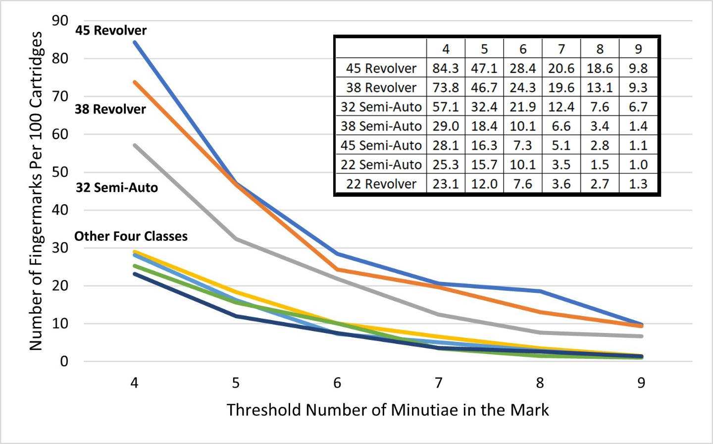

Figure 6. Number of fingermarks per 100 cartridges showing a given number of minutiae or more. The 45 and 38 revolver classes show the greatest numbers of fingermarks, the 32 semi-automatic class shows intermediate numbers, and the four other classes show smaller numbers that are similar to one another.

C. Expected Associative Values

Expected associative values (as measured by ESLRs) are closely associated with the numbers of minutiae. Figure 7 shows this relationship for the fingermarks in this study. There is a regular increase in Log₁₀ ESLR with the number of minutiae (although wide ranges are seen in the values for any given number of minutiae, and the values for different minutia numbers overlap considerably).

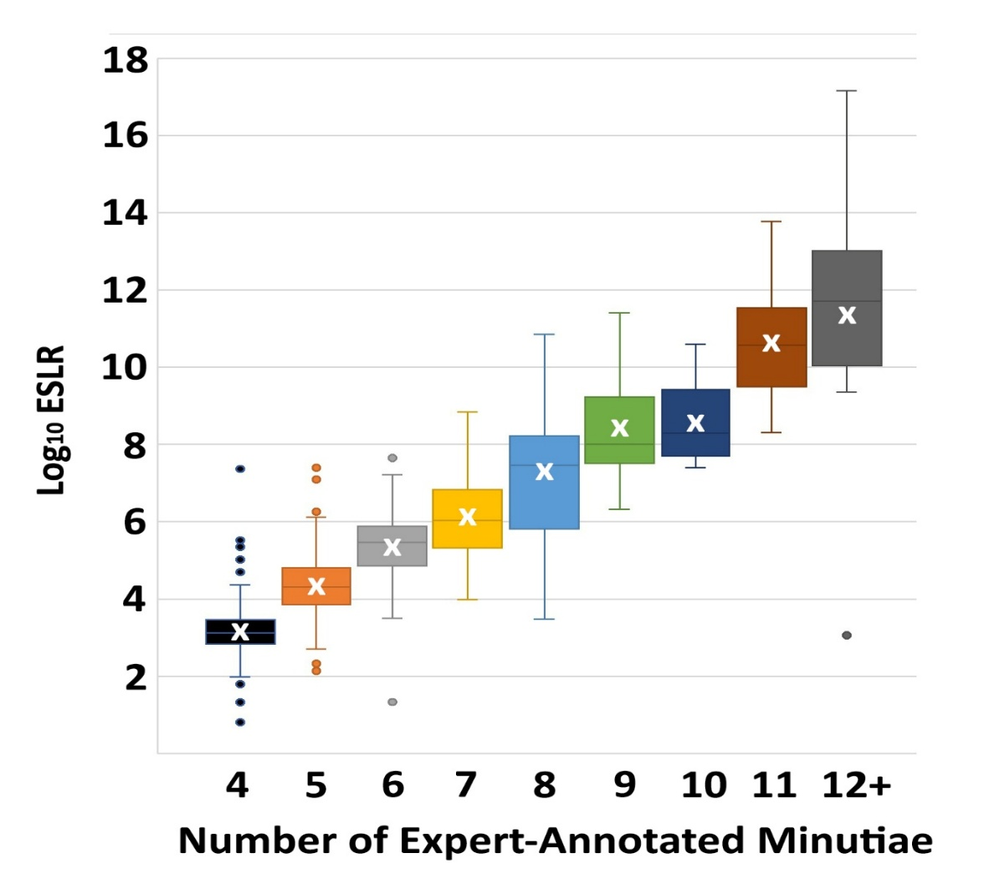

Figure 7. Box and Whisker Plot of Log₁₀ ESLR values for fingermarks in this study dataset categorized by the number of expert-annotated minutiae. Mean values for each minutia number are indicated by the “X”. The shaded boxes show the range covered by half of the values, the “whiskers” extending outside of the boxes show the range expected based on commonly accepted statistical criteria, and the dots show individual values that are outside this range and considered “outliers.”

Table 5 translates the mean values of the Log₁₀ ESLRs shown in Figure 7 to the ESLR values themselves. For example, the 4-minutia value indicates an association with equivalent strength to an event that occurs randomly once in 1500 times, the 5-minutia value indicates that for an event occurring randomly once in 22,000 times, and so forth, with the 12+ minutia value indicating that for an event occurring once in 220 billion times. ESLRs for the fingermarks are given in Table 6 showing the distribution among handgun type and caliber class. Differences among these categories are charted in Figure 8, which shows the numbers of NIFMs found exceeding a given Log₁₀ ESLR, per 100 ammunition cartridges examined. Table 7 gives the values that are charted in Figure 8.

Table 5. Associative Values indicated by the ESLR

Table 6. Log₁₀ ESLRs for 476¹ Fingermarks on Cartridges by Handgun Type and Caliber Class
¹ESLRs for two fingermarks were not measurable as method requires four minutiae other than the core. Two fingermarks included the core as one of only four minutiae, one a Semi-Auto/22 and one a Semi-Auto/38.

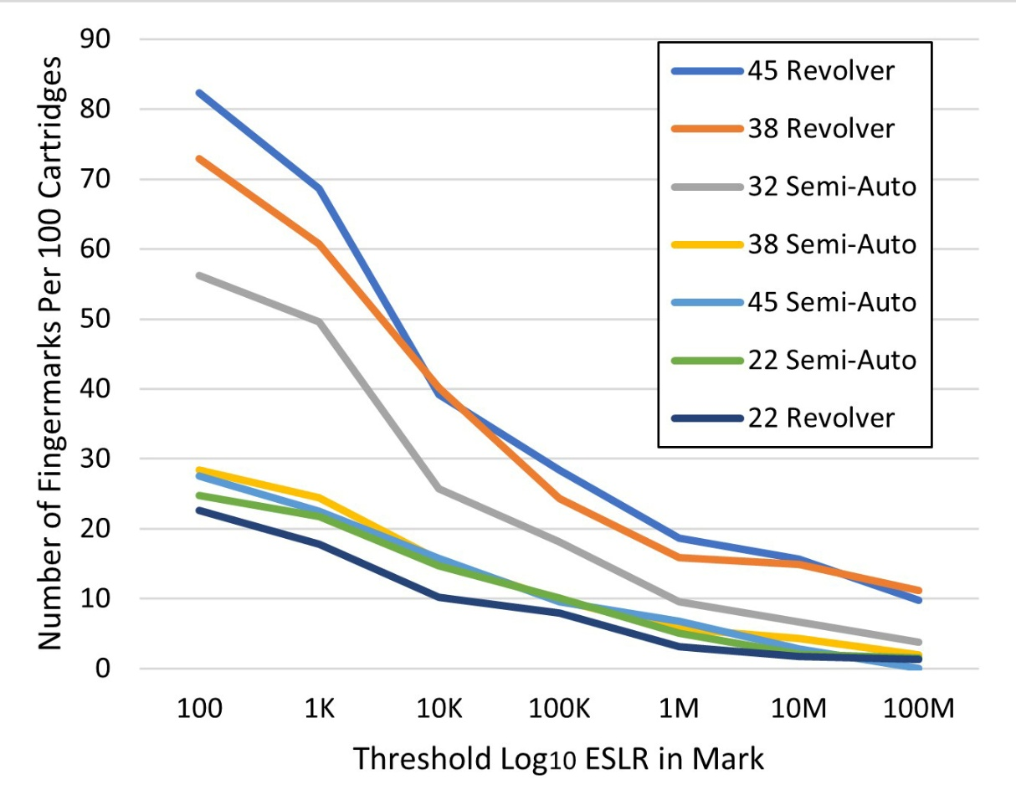

Figure 8. Number of fingermarks per 100 cartridges showing a given Log₁₀ ESLR or higher. Given the high correlation of the ESLRs with annotated minutiae (Figure 7), the trends closely follow those for seen for annotated minutiae (Figure 6).

Table 7. Number of Fingermarks Per 100 Cartridges Showing a Given Log₁₀ ESLR or Higher

The strong correlation of ESLRs with the number of minutiae (as shown in Figure 7) explains the similar appearance of the charts in Figures 6 and 8. As with the numbers of minutiae in Figure 6, Figure 8 shows higher ESLR values for the 45 and 38 revolver classes, intermediate values for 32 automatics, and smaller numbers, similar to one another, for the other four classes.
IV. Discussion and Conclusions

A. Finding of High Associative Values Among NonIdentifiable Fingermarks
Tables 3 and 4 show that many more NIFMs (414) than identifiable fingermarks (64) were found on loaded handgun ammunition. The associative values of the NIFMs by handgun type and caliber class are given in Table 8. Comparing Table 8 (NIFMs only) to Table 6 (all fingermarks, including IDs) shows, as expected, that most of the identifiable fingermarks had higher ESLRs. Figure 9 shows the proportions of NIFMs and identifiable fingermarks by Log₁₀ ESLR. Identifiable fingermarks dominate those with ESLRs exceeding 100 million, and NIFMs dominate those below 10 million.

However, the associative values of the NIFMs are very high. Based on the measured ESLR values, and following the EFSI Guideline for Evaluative Reporting [15], 35.7% of the 414 NIFMs recovered from the ammunition in this study would be rated as providing strong support for association, another 34.1% would be rated as providing very strong support, and 10.4% as providing extremely strong support (the highest level of reporting in [15]).

Table 8. Log₁₀ ESLRs for 412¹ NIFMs by Handgun Type and Caliber Class
¹ESLRs for two of the NIFMs having four minutiae were not measurable as in each of these marks one of the four minutiae was the core of the fingermark. One mark was Semi-Auto/22 and the other was Semi-Auto/38.

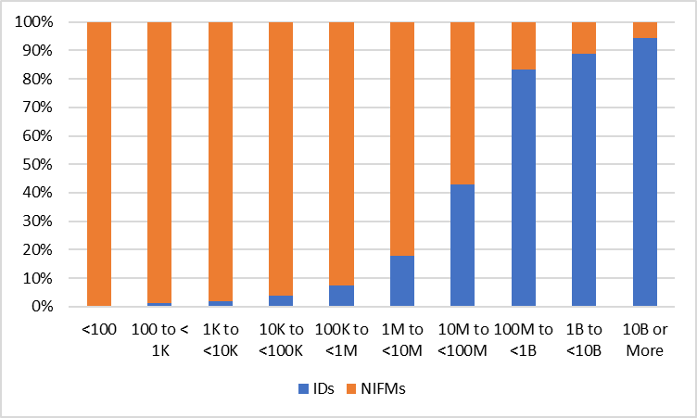

Figure 9. Proportions of NIFMs and identifiable fingermarks by Log₁₀ ESLR. Identifiable fingermarks dominate the ESLRs exceeding 100 million, while NIFMs dominate those below 10 million.

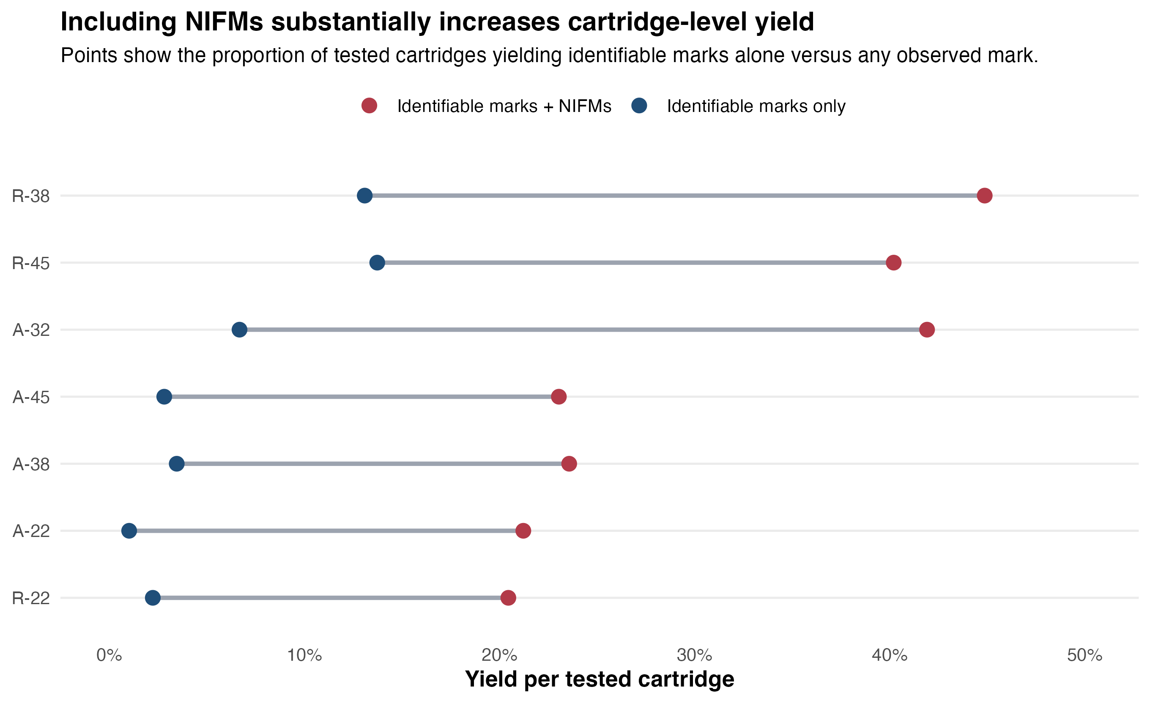
Figure 10. Estimated cartridge-level yield when only identifiable fingermarks are counted versus when NIFMs are included. The additional yield from including NIFMs is substantial across all handgun categories and is especially large in the revolver categories.

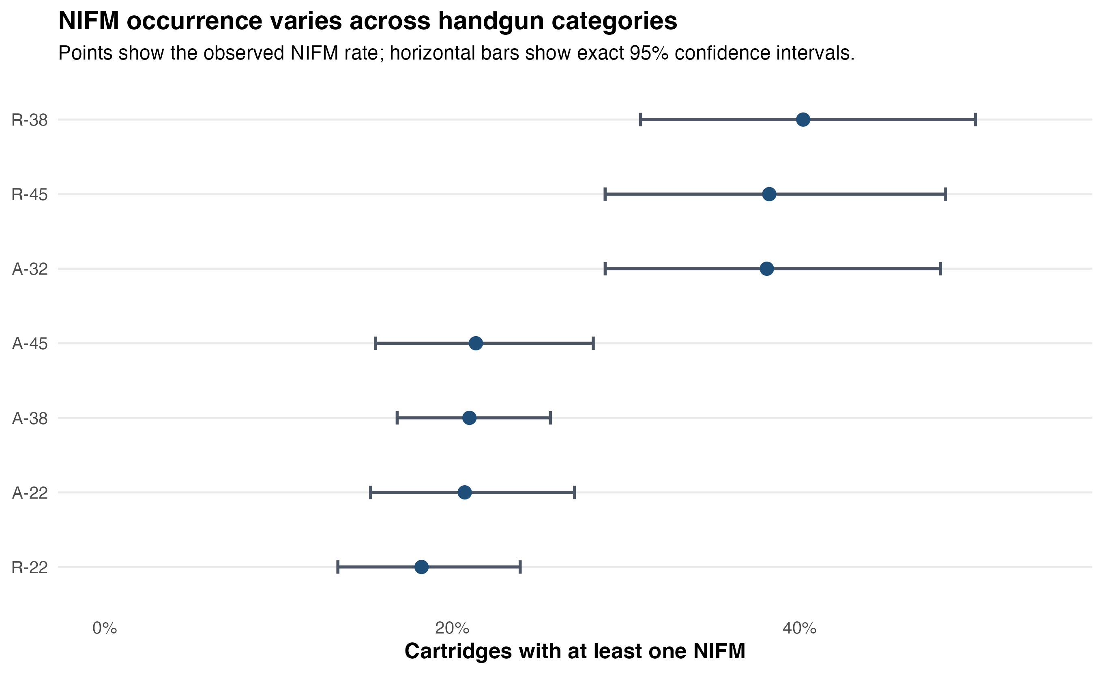
Figure 11. Estimated proportion of cartridges yielding at least one NIFM, by handgun type and caliber class, with exact 95% confidence intervals.

The findings clearly demonstrate the common occurrence of NIFMs of high associative value on loaded handgun ammunition. Although differences among handgun types and caliber classes occur, NIFMs providing strong support for association were found regularly (approximately 1/5 of the cartridges examined) for each of the handgun type and caliber classes. Semi-automatic ammunition in the 32 caliber category showed twice this amount and revolver ammunition in the 45 and 38 caliber classes showed NIFMs occurring on approximately half of the cartridges examined.

B. Significance of these Findings

Table 7 summarizes the findings for ammunition cartridges in each of the handgun type and caliber classes.

For example, the first row of Table 7 (reproduced below) shows 21.7% of the cartridges from semi-automatic handguns in the 22 caliber class with associative values rarer than an occurrence of one in 1000; 14.6% with values rarer than 1 in 10,000; and so forth, including 5.1% with values rarer than 1 in a million, reaching the highest level of reporting in the EFSI Guideline [15].

In casework, the number of ammunition cartridges in any loaded handgun will vary, and each cartridge provides an opportunity for recovery of fingermarks leading to evidence supporting or refuting the association of the handgun with an individual. Table 9 shows percentages of handgun loads in this study with cartridges showing a fingermark with a given Log₁₀ ESLR or higher.

For example, from the first row of Table 9, 47.6% of the semi-automatic handguns in the 22 caliber class showed fingermarks on at least one of their loaded ammunition cartridges showing associative values rarer than an occurrence of one in 1000; 42.9% showed values rarer than 1 in 10,000; and so forth, including 19.0% with values rarer than 1 in a million, reaching the highest level of reporting in the EFSI Guideline.[15] The other ammunition classes show associative values at this highest level ranging from a low of 10.3% (22 caliber revolver class) to a high of 41.2% (45 revolver class).

Table 9. Percentage of Handgun Loads with Cartridges Showing a Fingermark with a Given Log₁₀ ESLR or Higher

C. Applicability and Limitations

Impact Scenarios
Fingermarks on ammunition found loaded in handguns can result in material evidence in a variety of casework scenarios. Among the most important are:
- When the handgun is believed to have been discarded by a suspect while being chased from a crime scene
- When it is important to establish possession for a handgun found in an automobile or within a shared dwelling space
- When issues surround who has brought a handgun to a meeting or a scene of criminal activity
- When possession of the handgun can materially increase the penalties for an offense
- When possession of the handgun is a necessary element of the crime itself

Limitations Arising from the Scope and Choice of Research Parameters
The choice of methods and approach used in this research were suitable to meet the research goal of finding how often NIFMs occur on loaded ammunition and what range of associative values can be expected. Ammunition was collected from a reasonably representative set of handguns, well-established methods were used to detect and photograph the fingermarks, a highly experienced fingerprint expert evaluated the fingermarks, and associative values were measured using a well-characterized, peer-reviewed method.

During ammunition loading and collection, several factors known to affect the leaving of fingermarks were intentionally left uncontrolled in this research (with the purpose of providing a reasonably representative set of conditions, rather than controlling them). These factors included
- the loader’s susceptibility to leave fingermarks (which is known to vary among individuals)
- the cleanliness of the loader’s hands
- the presence or absence of corrosion or loose surface debris on the ammunition
- the technique used for loading the handgun (such as the use of speed loaders for revolvers, or magazine loaders for semi-automatic pistols)

These factors could be the subject of additional investigation which would provide insight into how significantly they influence the chances that a useful fingermark would be left on loaded ammunition. However, the contribution of such insights may be limited as the factors are usually unknown in actual casework.

Alternative, or more narrow classifications of handgun and ammunition types could result in additional distinctions. For example, the composition of cartridge casings (e.g. brass vs. nickel-plated), and overall differences in available surface area of cartridges (due to differences of length as well as diameter) were not investigated. This additional work could be of value to help with policy decisions if these decisions become dependent on specific types of handguns, ammunition sizes and ammunition compositions.

This research used two very well established and widely applied methods for fingermark visualization (cyanoacrylate, or CA fuming, followed by fluorescent dye staining). These methods were applied sequentially and if one or more NIFMs were found after CA fuming, the second method was not applied. Using fluorescent dye staining for all cartridges, or the inclusion of other more specialized methods of fingermark visualization, would increase the chances that more or better-quality fingermarks would be found.

The research used a single, highly experienced fingerprint expert to evaluate candidate NIFMs and annotate their minutiae. These activities are known to be expert-dependent, and the results could be influenced if a different expert were to perform these evaluations. This work did not include reinvestigation of this well-known source of variation.

The associative value of the NIFMs was measured using ESLRs (expected score-based likelihood ratios). This is one well-established, calibrated method to measure the associative value of a fingermark. However, there is no consensus or standardization regarding the use of this method, and the use of an alternative measurement method could change the results. To allow for this possibility, and preserve this project’s contribution, the entire dataset of NIFMs (original and annotated) has been published [16] and is available for further evaluation as measurement methods evolve.

Challenges for Transition to Practice and Implementation
The development and vetting of measurement methods to determine the associative value of comparisons of NIFMs to known fingermarks of an individual is one important challenge for transition to practice, but these methods will not be long in coming.[17] Of parallel importance is the need for a paradigm change that recognizes the associative value and utility of NIFMs.[18]

One major challenge is the long-standing forensic workflow practice that includes an all-or-nothing triage step that recognizes identifiable fingermarks as useful and dismisses any potential associative value for marks that fail to meet this threshold. Utilization of NIFMs as a new source of information would require adjustment of these long-standing forensic examination practices and balancing the level of effort required with the utility of the resulting associations. Among the forensic science community, there is uncertainty regarding what new levels of effort would be required, what alternative procedures would need to be developed, and what benefits would result.[2] The present research contributes to the body of work that shows an extremely high potential benefit: useful fingermarks with high associative value occur on nearly 6 times as many cartridges as when identifiable fingermarks alone are considered. However, an important limiting factor that remains is the uncertainty about the increased cost (largely the level of effort) which would be needed to recover and utilize this new form of information. This project used labor-intensive research laboratory methods for two of the necessary steps: photographic documentation (including manual multiple exposures and related image processing for individual cartridges) and annotation of minutiae (employing visual expert evaluation of each candidate NIFM). Accordingly, for a realistic measurement of the level of effort a follow-on study is required that would utilize more efficient imaging and evaluation technologies that are currently available in forensic laboratories.

D. Conclusion
The findings clearly demonstrate the common occurrence of NIFMs of high associative value on loaded handgun ammunition. For this application it has been shown under realistic operational conditions that a six-fold increase in useful associative information results when NIFMs are included along with conventional fingerprints. This finding is reasonably generalized to expect a similar increase when NIFMs are used for other items collected as evidence, or as part of the general fingerprint processing of crime scenes. These findings are based on loaded handgun ammunition and should be generalized to other evidence types with caution until comparable studies are conducted.

This is an extraordinary potential contribution – and one that does not require any additional investment in crime laboratory equipment nor any additional personnel skills. The use of NIFMs warrants immediate attention, with application to criminal investigations, the development and testing of alternative implementation protocols, validation of these protocols, and development of robust quality assurance procedures.

This research has answered the question of how often NIFMs occur on naturally loaded ammunition and what associative value can be expected. These findings allow an informed assessment of the potential utility of the approach and help set priority for development and validation of methods to exploit the use of NIFMs on ammunition. The NIFM dataset that has been developed is a lasting resource available for further examination as measurement and interpretive methods are refined.

The results of the present and prior research [8,9,18] have come to point that warrants dissemination beyond researchers and laboratory practitioners. The infrastructure to utilize these fingermarks is largely in place, but the impetus to do so, with increased levels of effort for analysis, procedural modifications and education, must come from a broader appreciation of the currently unexploited potential value of these marks. When this potential is understood by senior investigators, police chiefs, the legal community, and policy makers it is reasonable to expect that the motivation for investments in resources and tasking of the crime laboratory will be forthcoming.

V. References

1. Girelli, C.M., B.J. Lobo, A.G. Cunha, J.C. Freitas, and F.G. Emmerich, Comparison of practical techniques to develop latent fingermarks on fired and unfired cartridge cases, Forensic Sci Int 250:17-26, 2015.

2. Edmiston, K.E. and J. Johnson, Determining an optimal sequence for chemical development of latent prints on cartridge casings and shotgun shells, J Forensic Sci 54(6):1327-1331, 2009.

3. Girelli, C.M.A., M.A. Vieira, K. Singh, A.G. Cunha, J.C.C. Freitas, and F.G. Emmerich, Recovery of latent fingermarks from brass cartridge cases: Evaluation of developers, analysis of surfaces and internal ballistic effects, Forensic Sci Int 290:258-278, 2018.

4. Johnson, S., Examining the Effectiveness of Processing Fired Cartridge Cases for Latent Evidence, J Forensic Ident 69(1):27-34, 2019.

5. Swank, M. and C.E. Davis, Recovery Rates of Latent Prints on Firearm, Magazine, and Cartridge Evidence: An FBI Case Study. J Forensic Ident 71(1):3-10, 2021.

6. Dove, A., Natural Fingerprint Development on an Unfired Cartridge Case, J Forensic Ident 69(3):251-260, 2019.

7. Freeman, H.N., Magnetic Fingerprint Powder on Firearms and Metal Cartridges. J Forensic Ident 49(5):479-484, 1999.

8. Stoney, D.A., M. De Donno, C. Champod, P.A.Wertheim, and P.L. Stoney, Occurrence and associative value of non-identifiable fingermarks. Forensic Sci Int 309:110219, 2020.

9. Stoney, D.A. and P.L. Stoney, Utility of non-identifiable fingermarks. Forensic Sci Int 319:110630, 2021.3. Dove, A., Fingerprint Development on Cartridge Cases through the Electrodeposition of Gun Blue, J Forensic Ident 67(3):391-409, 2017.

10. Dominick, A.J. and K. Laing, A Comparison of Six Fingerprint Enhancement Techniques for the Recovery of Latent Fingerprints from Unfired Cartridge Cases. J Forensic Ident 61(2):155-165, 2011.

11. Spear, T., J. Clark, M. Giusto, N. Khoshkebari, M. Murphy, and J. Rush, Fingerprints and DNA on Cartridges and Cartridge Cases: How Likely?, California Association of Criminalists Semi-Annual Seminar, 2005. Available from:
https://oag.ca.gov/sites/all/files/agweb/pdfs/cci/reference/lpdnactg.pdf [Accessed 2/27/26]

12. International Fingerprint Research Group (IFRG), Guidelines for the Assessmentof Fingermark Detection Techniques. J Forensic Ident 64(2):174-200, 2014.

13. Girelli, C.M.A., M.A. Vieira, K. Singh, A.G. Cunha, J.C.C. Freitas, and F.G. Emmerich, Recovery of latent fingermarks from brass cartridge cases: Evaluation of developers, analysis of surfaces and internal ballistic effects, Forensic Sci Int 290:258-278, 2018.

14. Porter, G., R. Ebeyan, C. Crumlish, and A. Renshaw, A novel method for the photographic recovery of fingermark impressions from ammunition cases using digital imaging. J Forensic Sci 60(2):418-421, 2015.

15. European Network of Forensic Science Institutes, ENFSI guideline for evaluative reporting in forensic science 2015,
https://enfsi.eu/wp-content/uploads/2016/09/m1_guideline.pdf [Accessed 2-27-26]

16. Stoney, David (2024), “Non-Identifiable Fingermarks from Unfired Ammunition in Handguns”, Mendeley Data, https://data.mendeley.com/datasets/2hzvncvvpn/1, Accessed 4-25-25.

17. Cole, S.A., S. Kelley, B. Gardner, K. Khan, M. Neuman, and J.L. Sola, Introduction, Law, Probability and Risk, Volume 23, Issue 1, 2024, mgae006, https://doi.org/10.1093/lpr/mgae006, Accessed 4-25-25.

18. Stoney, D.A. and P.L. Stoney, How the work being done on statistical fingerprint models provides the basis for a much broader and greater impact affecting many areas within the criminal justice system, Law, Probability and Risk, Volume 23, Issue 1, 2024, mgae008, https://doi.org/10.1093/lpr/mgae008

Associative values are presented as randomly occurring events that would result in equivalent ESLR values. A more complete explanation of this approach is provided in [8].

